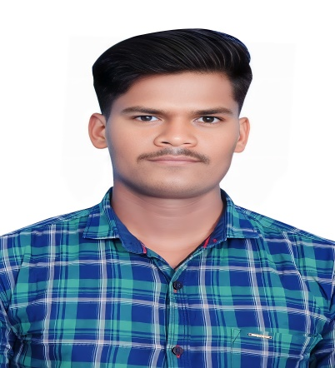
EDUCATION

2019-2022

2016-2018
Under graduation :BSC
College: SV Degree College, Atmakur, Nellore
Stream : Botany-Zoology-Chemistry (BZC)
CGPA : 8.07

Class: Intermediate(+2) ( Bi PC )
Collage: APJ Abdul Kalam Jr.college, Udayagiri

CGPA:7.5

2015-2016
Class: 10th std
School : MJP AP BC (Boys)WRIE School
Kota
CGPA: 7.7

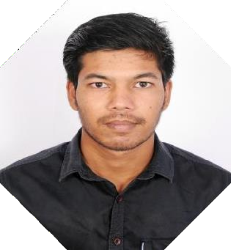

PETLURI NAGARJUNA
PROFILE
Looking forward to work in an organization with a challenging position to expand and utilize my learning,skills and knowledge,possess excellent communication skills and have an eye of detail.Flexible to work in any environment as required
SKILLS

Adaptability Creativity
Leadership
Time management

Team work Empathy
CONTACT PH : 9121489253
Email:arjunpn253@gmail.com
place : Nellore

TECHNICAL SKILLS

- LANGUAGES KNOWN: HTML ,beginner in python
- ADDITIONAL SKILLS: Microsoft Word, Microsoft PPT, Microsoft Excel.
- DATBASE SYSTEM: basics of SQL
- OPERATING SYSTEM: Windows, linux
- ONGOING ADD-ON COURSES: AWS(Amazon Web Services)

OTHER INTREST AND ACHIEVEMENTS

- Intrested in doing research and presenting papers on various new fields
- Volunteered in peer teaching
- participated in various inter-college activities

HOBBIES AND INTERESTS

- travelling
- Watching web series
- Reading historical books
- Cooking

KNOWN LANGUAGES
English Hindhi Telugu

PROJECTS

ACADAMIC PROJECT ON AQUACULTURE (ZOOLOGY)

- Observation on the aqua fields about fish growth, feeding and health condition and suitable environment for fish growth
- Observation of water and its PH value for the fish survival
- Used: pH meter to test water pH level, beakers, pond water and net.


I solemnly declare that all the information furnished in this document particulars is free of errors to the best of my knowledge and I hold the responsibility for the corrections of the above mentioned

Place: signature

Date: Nagarjuna.P

